Hazard identification form

For use with S1248_A – Job hazard analysis form
Job/task: |  |  |  | Date of assessment:
Assessment conducted by:
Department/work area(s):
Reviewed by:

Falls from elevation? | Slips/trips/falls on same surface? | Musculoskeletal disorders
Does the task require the employee to:  o Use a ladder?  o Use or work on a raised platform?  o Work on a mezzanine?  o Work on a scissor or boom lift?  o Work from forklift work platform?  o Work on a loading dock?  o Work on top of equipment?  o Use stairs?  o Other? | Is the work done in an area with:  o Congestion?  o Uneven walking surfaces?  o Material on floor?  o Cords/hoses on floor?  o Potential for spills?  o Potential for ice and/or snow?  o Poor lighting?  o Other? | Use observations to identify:  o Forceful exertions  o Awkward postures  o Static postures  o Repetitive motions  o Contact pressure/stress

Chemicals/hazardous materials with potential for inhalation? (Review SDS) | Chemicals/hazardous materials with potential skin contact? (Review SDS) | Non-ionizing and  ionizing radiation?
Is there a potential inhalation hazard from:  o Paints?  o Metal fumes and gases from welding/soldering?  o Dusts from grinding/sanding/blasting?  o Dusts/mists/vapors while filling machines, tanks, reservoirs etc.?  o Cleaning chemicals?  o Solvents or other volatile chemicals?  o Dip-tank operations?  o Compressed gases?  o Products of combustion and thermal degradation from (heating plastics or other material)?  o Oxygen-deficient atmosphere (confined space)?  o Other chemical hazards? | Work activities with the potential for skin or eye contact (Can damage skin/eyes by irritation, burn, sensitization or can be toxic when absorbed through skin or ingested):  o Corrosives (acids and caustics)?  o Irritants/sensitizers?  o Solvents?  o Lead wire or other metal contamination?  o Cryogenics (e.g. liquid nitrogen or oxygen)?  o Machining fluids?  o Other?  o Is there potential contact with bodily fluids? | Work activities, such as:  o Continuous noise?  o Impact noise?  o Vibration?  o Heat stress (hot environment)?  o Cold stress (cold environment)?  o Lasers?  o Ultraviolet or infrared light?  o Radiofrequency/microwave radiation?  o X-Rays?  o Other?
Electrical hazards? | Hot work? | Hazards from pressure?
Could employee be exposed to:  o Exposed electrical wiring or components?  o Arc flash?  o Other electrical hazards? | Does the work create or is the work done in proximity to:  o Flame and/or spark?  o Hot surfaces?  o Flammable or combustible chemicals?  o Other conditions that could create a fire? | Is the work done in proximity to or require the use of:  o Hydraulic pressure?  o Pneumatic pressure?  o Water pressure?
Mechanical hazards? | Mechanical hazards (examples) | Vehicles?
Does the work require using equipment with moving parts:  o Does equipment cut, bend, shear, punch?  o Is there access to the point of operation? (e.g. saws, press brake, shear, punch press)  o Are there rotating shafts/shaft projections?  o Are there rotating chucks, drill bits?  o Are there reciprocating or transverse motions?  o Nips points at fly-wheels, augers?  o Nip points at in-running rollers?  o Nip points at belts, pulleys, chains, gears (mechanical power transmission)?  o Are robotics present?  Could employee be struck or cut by:  o Saw blades?  o Abrasive wheels?  o Hand tools?  o Knives?  o Other items or tools? | Review the Oregon OSHA machine safeguarding publication (bit.ly/3TC4s8I) and/or the OSHA e-tool (bit.ly/3TteMzy).  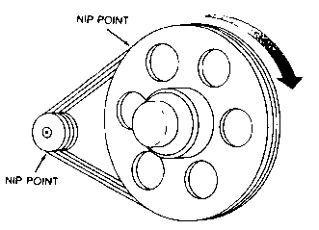  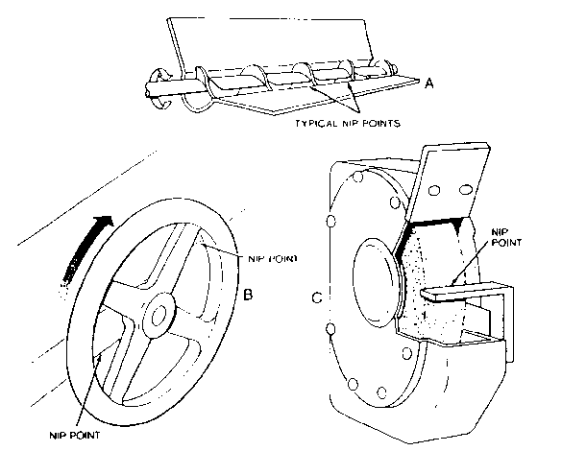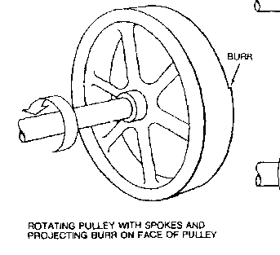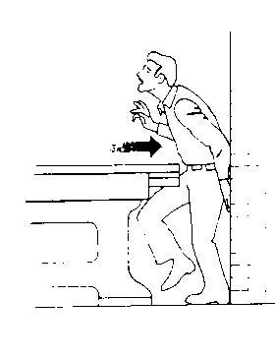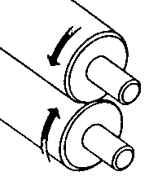  (Images from Oregon OSHA) | o Does the work require use of a vehicle?  o Is there vehicle traffic in the area?

Other hazards and observations:

